S.4.1 Sampling locations for the experimental fieldwork
A) De Panne site
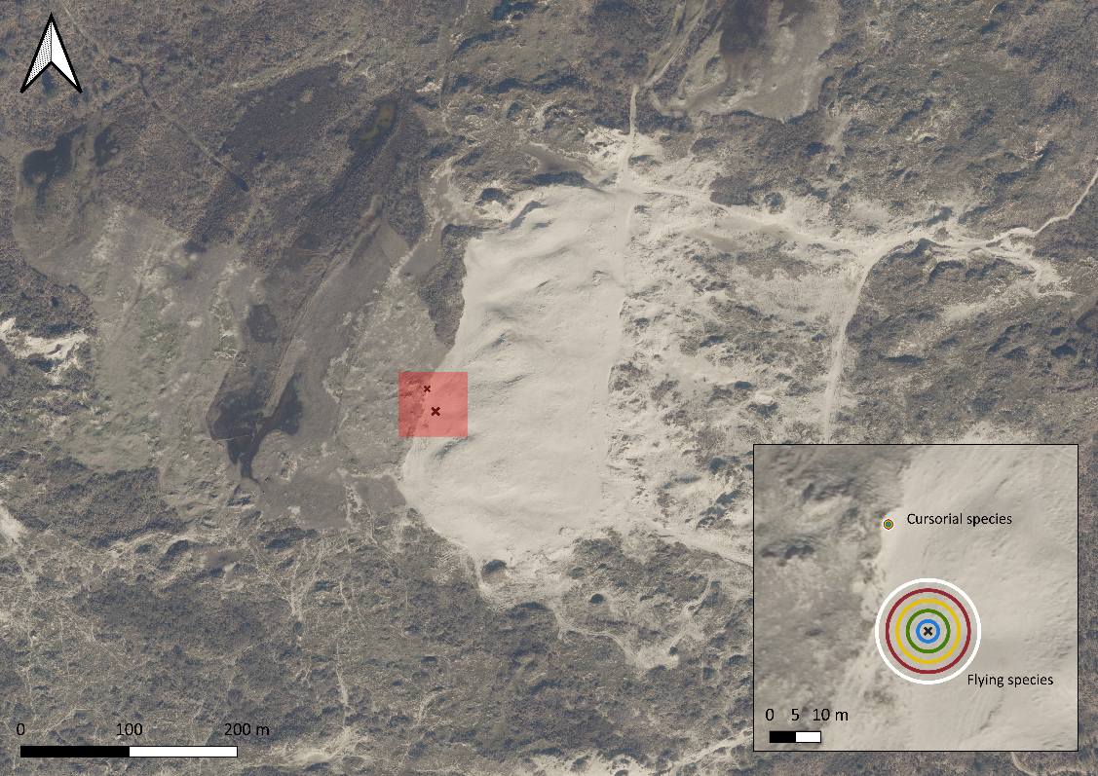
B) Kalmthout site
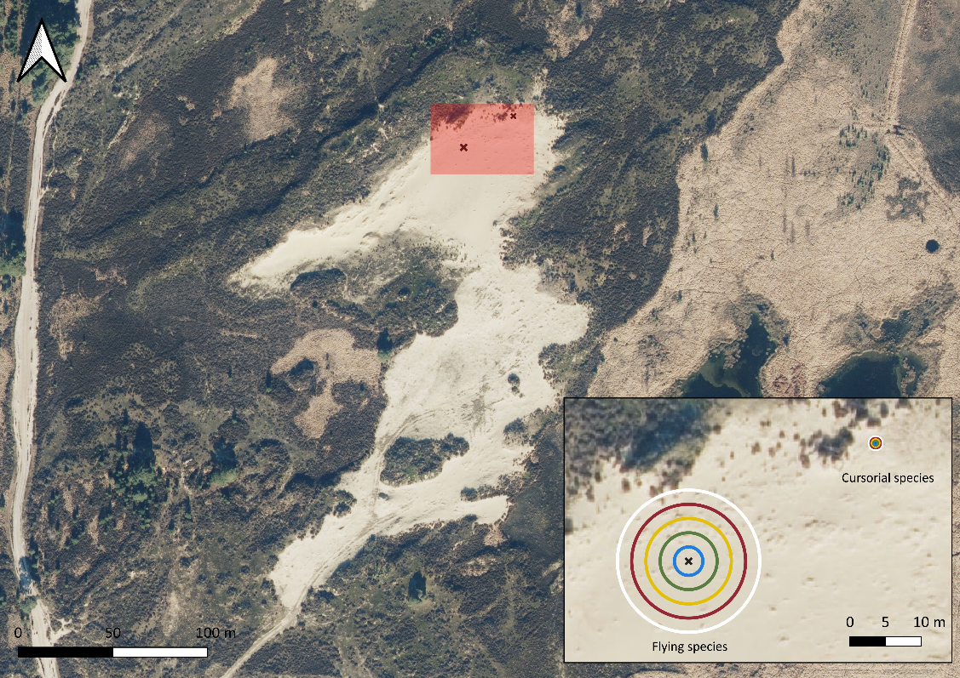

Figure S.4.1: The two sampling sites in Belgium. A) Open sand of grey dunes bordering dune grassland and shrubland. B) Open sand surrounded by dry and wet heathland patches. Black crosses indicate the location of the experimental arenas.

